

## ACADEMIC WRITING

A RECAP

TABLE OF CONTENTS

1. Formal Style
2. Essay Structure
3. Five-paragraph Essays
4. Thesis Statements
5. Evidence
6. CRAAP Analysis
7. They Say / I Say
8. Addressing the Opposition
9. In-text Citations and References Page

FORMAL STYLE

Academic vocabulary

Words with neutral connotations

Fewer contractions

Longer paragraphs

Formal citations (e.g. APA)



ESSAY STRUCTURE

Introduction with thesis

Body paragraphs Conclusion References



WHAT IS THE FIVE-PARAGRAPH ESSAY?

# 01

05

Conclusion summarizing the three- part argument

04

Body paragraph three: argues third part of thesis

03

Body paragraph two: argues second part of thesis

02

Body paragraph one: argues first part of thesis

Introduction with three- part thesis at the end of the paragraph

WHAT’S GOOD ABOUT THE 5P ESSAY?

(SEE NOTES AT BOTTOM OF SLIDE)

Teaches basic essay structure

Easy-to- follow formula

Easy to mark

WHAT’S THE PROBLEM WITH THE 5P ESSAY?

(SEE NOTES AT BOTTOM OF SLIDE)

Reductive, simplistic

Produces forced arguments

No “real- world” equivalent



PROBLEM: ARGUING-BY-NUMBERS

* Let’s say you are writing an essay about whether you should break up with your partner.
* You have two clear points:
  + your partner has started robbing little old ladies
  + your partner has stolen all the money from your bank account.
* Would you REALLY need a third point here?

A thesis is a summary of what your essay will show or argue or prove

THESIS

It is usually one or two sentences



It is specific enough to tell the reader what your overall argument will be, but it isn’t overburdened with details

EVIDENCE

* Subject all your sources to the CRAAP analysis
* When incorporating your evidence, use the “They say, I say” formula

EVALUATING AN ARTICLE WITH CRAAP

|  |  |
| --- | --- |
|  |  |
| Current? | How recent is your article? |
| Relevant? | How well does the article answer your question? |
| Authoritative? | Is the writer an authority on the topic? If not, has the writer used reliable research from recognized experts? |
| Accurate? | Is the information accurate? Is it cited so that we can check? Because we can’t fact-check every fact in everything we read, we have to rely on the credibility of the author and source. |
| Purpose/point of view? | Is the writer informing or persuading? Why does the writer want to persuade you? Does the write have something to gain from |

THEY SAY / I SAY

YOUR ESSAY IS A CONVERSATION BETWEEN YOU AND YOUR RESEARCH



YOUR RESEARCH = WHAT DO “THEY” (YOUR SOURCES) SAY

WHAT DO YOU SAY IN RESPONSE?



THEY SAY / I SAY

|  |  |
| --- | --- |
| **They say: incorporate your research** | **I say: respond to the research** |
| According to an article in The Globe and Mail, “Blah blah blah blah blabbity blah blah” (Wrax, 2020). | This suggests that we should continue to…. |
|  | This is a reasonable argument because… |
|  | This sounds like a reasonable  argument but it overlooks a key point… |

Addressing the opposition is where you consider the opposing view to your own argument

## OPPOSITION

You show that you have thought about the opposing view

You acknowledge any valid points in the opposing view

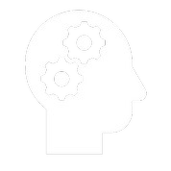

You refute the opposing view. This means you show why, even after considering the opposing view, you still hold your belief

Therefore, I must break up with her.

Refute the opposing view: However, her immoral behaviour is intolerable to me, and I cannot trust her after she stole my life-savings.

Acknowledge any valid points: This is true: despite her behaviour, I do still love my partner, and we co-signed a mortgage.

ADDRESSING THE OPPOSITION

Introduce the opposing view: Some people (such as my mother) might argue that I should stay with my partner because I still love her, and we just bought a house together.

Introduce

Acknowledge

Refute

Reinforce thesis

CITATIONS

In-text citations

Reference s page with full APA

citations

IN-TEXT CITATIONS

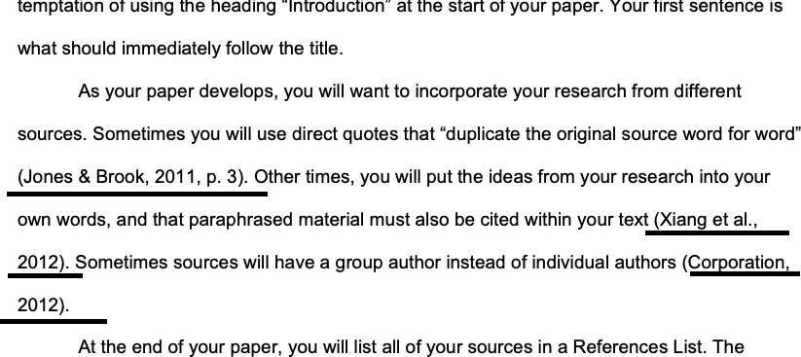

REFERENCES

